Modelling the respiratory system

**Materials**

* A plastic bottle (2L)
* A straw
* An elastic band
* Scissors
* 2 balloons
* [Play dough](https://www.amazon.com/Play-Doh-Modeling-Compound-Non-Toxic-Exclusive/dp/B00JM5GW10/ref=as_li_ss_tl?s=books&ie=UTF8&qid=1535312631&sr=1-1-spons&keywords=play+dough&psc=1&linkCode=ll1&tag=mummummum-20&linkId=ae5f08e735ee2c2684fd24e05e732362&language=en_US)

**INSTRUCTIONS**

1. Carefully cut your bottle to about half the size.
2. Tie a knot in one end of one balloon and cut off the fat end.
3. Stretch the balloon around the bottom of your plastic bottle.
4. Put a straw in the neck of the other balloon and secure tightly with the elastic band but not so much that you crush the straw. The air must flow through, so test it with a little blow through the straw to see if the balloon inflates.
5. Put the straw and the balloon into the neck of the bottle and secure with the play dough to make a seal around the bottle – make sure that again, you don’t crush the straw.
6. Hold the bottle and pull the knot of the balloon at the bottom.

**Observations**

What happens to the balloon inside the bottle when we pull on the balloon at the bottom?

__________________________________________________________________________________________________________________________________________________

What happens when we let go of the balloon at the bottom?

__________________________________________________________________________________________________________________________________________________

Using what you know about breathing and further research, explain what is happening in this model and how it is similar to your own respiratory system.

__________________________________________________________________________________________________________________________________________________

____________________________________________________________________________________________________________________________________________________________________________________________________________________________________________________________________________________________________

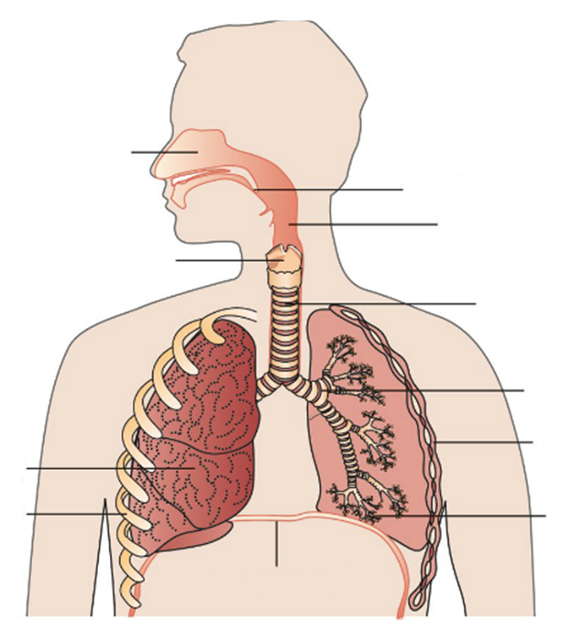

**1**

**2**

**3**

**4**

**5**

**6**

**7**

**9**

**10**

**8**

|  |  |
| --- | --- |
| Structure | Function |
| 1 |  |
| 2 |  |
| 3 |  |
| 4 |  |
| 5 |  |
| 6 |  |
| 7 |  |
| 8 |  |
| 9 |  |
| 10 |  |